Call for Szeged International Biblical Conference Scheduled date 2022 August 22-24
Centuries of Biblical Hermeneutics
In 2022, we are going to publish the Hungarian translation of the volume entitled Handbuch der Bibelhermeneutiken (Biblical Hermeneutics): de Gruyter, Berlin 2016, edited by Oda Wischmeyer, that has been translated and proofread by some 60 expert professors who teach in Hungarian higher education.
For us, the great value of Oda Wischmeyer's volume is the crossing of confessional boundaries while presenting some of the most prominent representatives of the subject. This voluminous and highly valuable publication also presents the intellectual experiments of the Christian Church over the centuries, by which the authors have attempted to grasp the Divine Doctrine on the basis of the knowledge and philosophy of their time. Due to today’s cultural tendencies, these efforts have become something like forgotten Christian knowledge.
During the translation project, the idea was born that the Hungarian translation of this publication could be duly celebrated in August 2022 by presenting the hermeneutical views of the ancient, medieval, and modern authors that were omitted from the Biblical Hermeneutics volume of Oda Wischmeyer. This could be done at a thematic conference in Szeged. In addition to the viewpoints of German-speaking universities, we would like to publish hermeneutical views of important biblical scholars from mainly Italy, Spain, and North America at the Szeged International Biblical Conference, and then edit a new volume on the basis of the conference contributions in order to counteract the current Christian cultural amnesia.
In the attached proposal, we put forward our ideas in 12 sections, proposing specific authors or a piece of work by a particular author on which to focus in order to develop a hermeneutical view. A brief guide to the methodology of each study is attached.
We would like to have one Hungarian and one foreign professor in charge of each section. Together, they should finalize the list of scholars we intend to invite based on our recommendations. This means that it is possible to deviate from, change or add names to the present list of recommendations based on the suggestions of the section leaders. We particularly recommend to give priority to former researchers who have carried out research at your university, some of which have made the reputation of your institute.
We need funding to organise the conference, which can easily be obtained from the Hungarian Cultural Government when we submit the list of speakers and universities applying for the conference in good time.
Therefore, please declare by 30th August 2021 that your university or institute agrees with the aims of the Szeged International Biblical Conference 2022 and will be represented at the conference with one or more speakers.
To apply for the conference, a lecturer must send a preliminary abstract (10-20 lines) by 30th January 2022, stating the lecturer's current academic position and providing contact details of their curriculum and publication list.
We look forward to receiving your application.
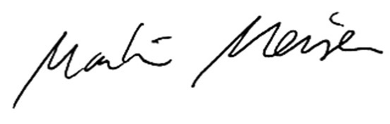
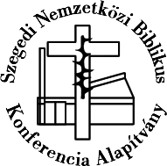
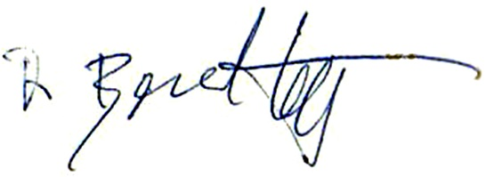
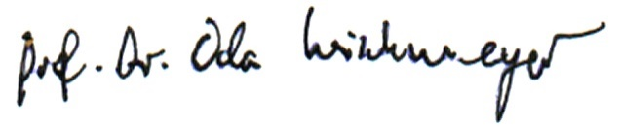
,Best regards
on the feast of Saint Benedict 11th July 2021

Dr. György Benyik PhD
Director Foundation of Szeged International Conference

Prof. Dr. Martin Meiser
University Saarland

Prof. Dr. Szabolcs Anzelm Szuromi
PÁZMÁNY PÉTER CATHOLIC UNIVERSITY in Budapest

Prof. em. Dr. Dr. h.c. Oda Wischmeyer
Friedrich-Alexander-Universität Erlangen-Nürnberg

